**St Michael’s Church of England High School**

**Maths Curriculum Plan**

**2024 – 2025**

**Maths**



**Mathematics Intent:**

Our ambitious curriculum aims to develop pupils that can investigate, hypothesize, prove and generalise using the overarching mathematical components; number explorations, geometric reasoning, proportional investigations and graphical representations. This spiral curriculum fully fosters a mastery approach to learning, to which knowledge is challenged, developed and secured by providing pupils with tasks that promote depth rather than breadth of learning. We encourage students to use models and manipulatives to support the development of the mathematical components. The curriculum provides opportunities to develop mathematics in the wider world including application to financial, career, logic and cross curriculum topics. Sequencing of tasks have been designed to maximise interleaving strategies by encouraging cross topics links and application. Pupils’ progress will be tracked and monitored through frequent, accurate and effective formative and summative assessments. These will inform the pupils learning over time and inform teachers of next steps in their planning and teaching.

**The Maths National Curriculum**

The national curriculum for mathematics aims to ensure that all pupils:

* become fluent in the fundamentals of mathematics, including through varied and frequent practice with increasingly complex problems over time, so that pupils develop conceptual understanding and the ability to recall and apply knowledge rapidly and accurately
* reason mathematically by following a line of enquiry, conjecturing relationships and generalisations, and developing an argument, justification or proof using mathematical language
* can solve problems by applying their mathematics to a variety of routine and non-routine problems with increasing sophistication, including breaking down problems into a series of simpler steps and persevering in seeking solutions
* Mathematics is an interconnected subject in which pupils need to be able to move fluently between representations of mathematical ideas. The programmes of study are, by necessity, organised into apparently distinct domains, but pupils should make rich connections across mathematical ideas to develop fluency, mathematical reasoning and competence in solving increasingly sophisticated problems. They should also apply their mathematical knowledge to science and other subjects.
* The expectation is that the majority of pupils will move through the programmes of study at broadly the same pace. However, decisions about when to progress should always be based on the security of pupils’ understanding and their readiness to progress to the next stage. Pupils who grasp concepts rapidly should be challenged through being offered rich and sophisticated problems before any acceleration through new content. Those who are not sufficiently fluent with earlier material should consolidate their understanding, including through additional practice, before moving on.

**Working mathematically**

Through the mathematics content, pupils will be taught to:

* Develop fluency
  + Consolidate their numerical and mathematical capability from key stage 2 and extend their understanding of the number system and place value to include decimals, fractions, powers and roots
* Select and use appropriate calculation strategies to solve increasingly complex problems
  + Use algebra to generalise the structure of arithmetic, including to formulate mathematical relationships
  + Substitute values in expressions, rearrange and simplify expressions, and solve equations move freely between different numerical, algebraic, graphical and diagrammatic representations [for example, equivalent fractions, fractions and decimals, and equations and graphs]
  + Develop algebraic and graphical fluency, including understanding linear and simple quadratic functions
  + Use language and properties precisely to analyse numbers, algebraic expressions, 2-D and 3-D shapes, probability and statistics.

**Reason mathematically**

* + Extend their understanding of the number system; make connections between number relationships, and their algebraic and graphical representations
  + Extend and formalise their knowledge of ratio and proportion in working with measures and geometry, and in formulating proportional relations algebraically
* Identify variables and express relations between variables algebraically and graphically
  + Make and test conjectures about patterns and relationships; look for proofs or counter examples
  + Begin to reason deductively in geometry, number and algebra, including using geometrical constructions
  + Interpret when the structure of a numerical problem requires additive, multiplicative or proportional reasoning Explore what can and cannot be inferred in statistical and probabilistic settings, and begin to express their arguments formally.

**Solve problems**

* + Develop their mathematical knowledge, in part through solving problems and evaluating the outcomes, including multi-step problems
  + Develop their use of formal mathematical knowledge to interpret and solve problems, including in financial mathematics
  + Begin to model situations mathematically and express the results using a range of formal mathematical representations
  + Select appropriate concepts, methods and techniques to apply to unfamiliar and nonroutine problems.

**Maths Implementation:**

**Schemes of work**

Pupils will follow the curriculum designed by Sparx Maths. This scheme is based on retrieving and deepening topics so that all pupils are progressing and remembering content over time. Faculty development meetings are used to discuss the pitch of lessons for different ability groups, as well as exploring the right technique for the pupils in our classes.  Assessment from Sparx maths will be used to track pupil progress on a national level – enabling the comparison of data to check true progress. Results inform the subject content and depth of future topics, as well as adjustments in homework topics. We adjust the sequencing of learning for our individual classes and the year group as a whole accordingly.

**Applying the skills students have been taught**

Formative assessment will be based on the topics they have covered in class and homeworks. This will be used to assess the learning of the current component. This will likely be seen in books as ‘Impact Tasks.’ Impact tasks will be used to assess a topic or new knowledge that has just been taught.

Summative assessments will be based on whole components and retrieval tasks over time. Pupils will be fed back on the completion of these with clear targets to how to improve. Time within the schedule has been left to give reteach opportunities to allow teachers to challenge, develop and secure any gaps in knowledge.

Year 7 will also complete a baseline assessment by Sparx. This data is compared and analysed with national data so that adjustments can be made in the latter months of the scheme of learning to ensure gaps, weaknesses and development opportunities are planned and well resourced. Each termly assessment will be compared nationally in order to track pupils in a wider picture. This will give detailed data in order to run accurate and effective interventions.

**Threads of Knowledge**

In order to ensure the ambitious curriculum is built on, developed and well sequenced. The key components of learning have been identified in the curriculum planning as threads of knowledge. The threads of knowledge build on prior knowledge, so that the progression of the skill is clear to both pupil and teachers.

|  |
| --- |
| Key Stage 3 |

**Big Ideas:**

|  |  |  |  |  |
| --- | --- | --- | --- | --- |
| **Big Ideas** | | | | |
| **Numerical Explorations** | **Geometric Reasoning** | **Proportional Understanding** | **Algebraic Representations** | **Statistical and Probable Reasoning** |

Year 7:

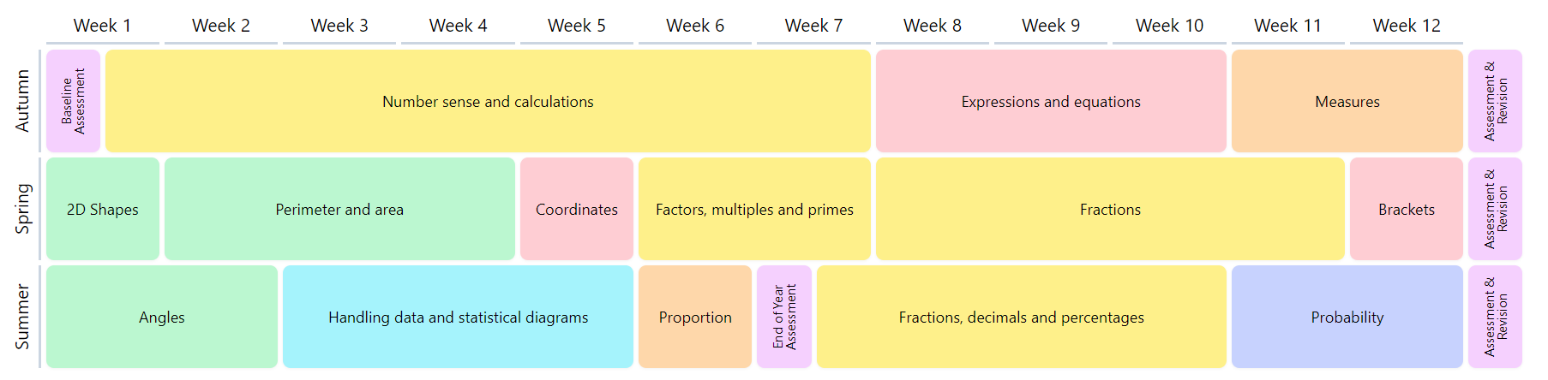

Year 8:

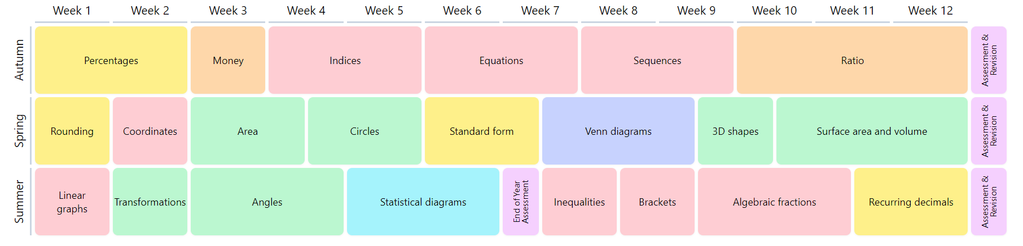

Year 9:

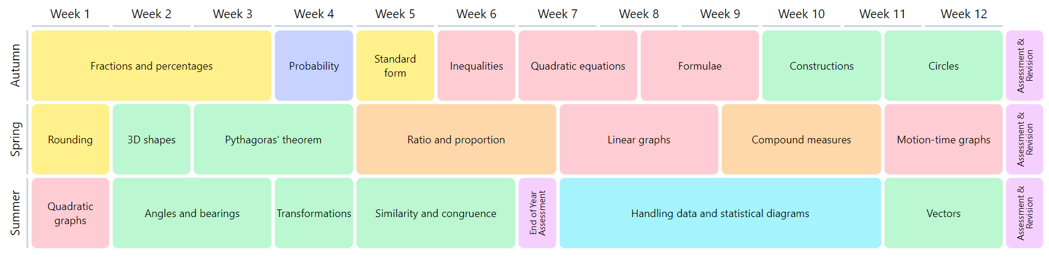

Due to the mastery approach adopted by the curriculum design, there is the expectation to intertwine as many topics as possible while learning the overarching component. Despite the overarching emphasis concentrating on, for example negative numbers, there is the opportunity to apply this concept to using algebraic terms and to explore negative number graphically, or within transformations to name a few. However, if the pupils have not mastered a key component, the pupil does not move on. The calendar proposed to each section was produced to provide a potential timeline for a generic progression through the concept, and aid the explicit incorporation of topics that intertwine with the component. This would not be suitable for all pupils – so would not progress until the key component is ‘mastered,’ by allowing more time for procedural practice, retrieval and investigation of methods.

There is a spiral – so in each year group they are focusing on the same overarching subsection of mathematics; Algebraic representation, proportion reasoning etc. Year 7 has one less algebraic manipulation and this reflects the opportunity to cement the fundamentals of number and geometry before applying the algebraic manipulation of these concepts. This is also to take into account those students that are not secondary ready – allowing intervention for the primary objectives, whilst the remainder have the opportunity to gain a deeper knowledge through retention, complexity or application of concept.

Mathematical celebrations are incorporated into medium term plans e.g. ‘NSPCC Number day’ and ‘International Pi Day.’ Feature weeks are also mapped under the heading: Financial Resilience Week, Strategy Week and Maths Week. During these weeks we design resources and activities that stretch the pupils reasoning and understanding of mathematics in a wider sense. This can include application to cross curricula topics, financial understanding such as mortgages and their problem solving skills through exploration of coding and logical thinking games.

|  |
| --- |
| Key Stage 4 |

All pupils will sit the Edexcel Examination Board. This consists of 3 papers sat in the examination series of Year 11: one non-calculator paper and 2 calculator papers.

This temporary sequence has been developed to allow students to get secure foundations of numeracy, proportional and algebraic concepts as well as expanding on prior knowledge to extend logical and problem - solving strategies.  It is based on interleaving topics so that there is an opportunity to revisit prior knowledge or to scaffold to ensure new content is linked to existing schemas with ease as well as giving opportunities for constant recall to prevent forgetting. Therefore, components have been spread so that algebra, number and geometry are split amongst the weeks, so that they return to that area of mathematics weekly to stop displacement of knowledge. Ratio and proportion is a thread of weaknesses so it runs throughout and is revisited is as many different topics as possible to ensure students are confident to use the concept in a range of topics. Underpinning the curriculum is the application of learning to the professional expectations of the modern world, using problem solving and logical thinking.

It is to raise ambition of the pupils whilst also providing support. As such, the medium term plans are separated into foundation, limited higher and higher. All pupils will learn a consistent topic or theme for the week but it is both broken down and developed so that all pupils can develop strengths and support weaknesses. The majority of pupils will be aiming to sit the higher paper in their examination series.

|  |  |  |  |  |  |  |
| --- | --- | --- | --- | --- | --- | --- |
|  | Autumn 1 | Autumn 2 | Spring 1 | Spring 2 | Summer 1 | Summer 2 |
| Year 10 | Angles, Polygons & Parallel Lines  Pythagoras’ Theorem  & Trigonometry  Perimeter, Area & Circles  3D Forms & Volume: Cylinders, Cones & Spheres | Index Laws  Order of Operations  Algebraic Expressions  Inequalities  Sequences  Quadratics  Simultaneous Equations | Fractions Manipulation  Number Decompositions (Factors, multiples, primes)  Standard Form  Percentage Manipulation  Ratio  Proportional Reasoning. | Probability & Venn Diagrams  Averages & Range  Represent & Inter. Data & Scatter Graphs  CF, Box Plots & Histograms | Constructions, Loci & Bearings  Multiplicative Reasoning inc. Speed Density Pressure  Similarity & Congruence in 2D and 3D | Graphs: Real Life & Line Segments  Linear Graphs y = mx + c  Quadratic, Cubic & other graphs  Circle Theorems & Circle Geometry  Vectors only |
| Year 11 | Standard Form  Algebraic Expressions  Prime, Factors and Multiples,  Angle Facts  Rounding/Estimation  Expanding and Factorising  Angles in Polygons  Percentages  Pythagoras Theorem  Ratio Problems  Venn Diagrams  Solving Equations | Angles in Parallel Lines  Quadratic Expressions  Box Plots  Probability  Factorising Quadratics  Scattergraphs  Area of Circle  Cumulative Frequency  Volume  Equation of a line  Compound Measures  Proportions: Direct and Indirect  Reflection  Rearranging formula  Vectors  Sequences Linear | Sequences  Inequalities  Ratio and Proportion  Simultaneous Equations  SOHCAHTOA  Circle geometry  Mean from tables  Similarity and congruency  Interest  Probability and Diagrams | Revision: Skill Gaps  Constructions  Loci  Bearings  Plans and Elevations  Time series  Invariance  Proof  Transformations – including graphical  Histograms | Revision: Skill Gaps | Exams |

|  |
| --- |
| Key Stage 5 |

|  |  |
| --- | --- |
| A level Maths | |
| Exam board: | **AQA** |
| Paper 1: All pure content | |
| Paper 2: Pure Content and Mechanics | |
| Paper 3: Pure Content and Statistics | |

|  |  |  |  |  |  |  |  |
| --- | --- | --- | --- | --- | --- | --- | --- |
| How are the Big Ideas developed through Key Stage 5 | | | | |  |  |  |
|  |  |  |  |  |  |  |  |
| Year 12 Pure | Algebra and Functions | Coordinate Geometry | Sequences and series | Trigonometry | Exponentials and Logarithms | Differentiation | Integration |
| Year 12 Statistics | Statistical Sampling | Data presentation and interpretation | Probability | Statistical Distributions | Statistical hypothesis testing |  |  |
| Year 13 Pure | Algebra and Functions | Coordinate Geometry | Sequences and series | Trigonometry | Exponentials and Logarithms | Differentiation | Integration |
| Year 13 Mechanics | Vectors | Quantities and units in mechanics | Kinematics | Forces and Newton’s Laws | Moments |  |  |

|  |  |  |  |
| --- | --- | --- | --- |
| Teaching Schedule | | | |
|  | **Autumn Term** | **Spring Term** | **Summer Term** |
| Year 12 | Problem Solving  Surds and Indices  Quadratic Functions  Equations and Inequalities  Coordinate Geometry  Trigonometry  Polynomials  Graphs and Transformations | The Binomial Expansion  Differentiation  Integration  Exponentials & Logarithms | Statistical Sampling  Data presentation and interpretation  Probability  Statistical Distributions  Hypothesis testing |
| Year 13 | Proof  Trigonometry  Sequences and Series  Functions  Differentiation  Trigonometric Functions& Identities  Algebra  Integration  Parametric Equations  Vectors  Numerical Methods | Vectors  Kinematics  Forces and Newton’s Laws  Moments | Revision |

|  |  |  |  |  |  |  |
| --- | --- | --- | --- | --- | --- | --- |
| Maths Curriculum Plan | | | | | | |
|  | **Autumn 1** | **Autumn 2** | **Spring 1** | **Spring 2** | **Summer 1** | **Summer 2** |
| Year 7 | Number Application: Negative Numbers | Motor Skills:  Symmetry, Angles and Charts | Shape and Space Awareness: Number within shape | Number Explorations: Factors Multiples and Primes | Proportions: Ratio manipulation | Algebraic Explorations: Pattern spotting and sequencing |
| Big Idea | **Numerical Explorations** | **Geometric Reasoning** | **Geometric Reasoning** | **Numerical Explorations** | **Proportional Understanding** | **Algebraic Representations** |
| Enhanced Learning opportunities | Reading, mathematical history | Artistic interpretation  Fibonacci Day | Artistic interpretation. Architecture awareness  Pi Day | Impact on financial services | Problem solving and logistics week | Strategy and Logic week |
| Year 8 | Number Application: Probabilities | Motor Skills Angle facts and constructions | Algebraic Manipulation: Creating expressions and equations | Number Explorations: Fractions, Decimals and Percentages | Proportions: Ratio in financial decisions | Algebraic Explorations: Straight line graphs and rate of change |
| Big Idea | **Numerical Explorations** | **Geometric Reasoning** | **Algebraic Representations** | **Numerical Explorations** | **Proportional Understanding** | **Statistical and Probable Reasoning** |
| Enhanced Learning opportunities | Reading, mathematical history | Artistic interpretation  Fibonacci Day | Artistic interpretation. Architecture awareness  Pi Day | Impact on financial services | Problem solving and logistics week | Strategy and Logic week |
| Year 9 | Number application:  Geometric Shapes | Motor Skills: 2D and 3D Shapes | Algebraic Manipulation: Equation and expression applications | Number explorations: Data comparisons | Proportions: Ratios in context | Algebraic Exploration: Graphical representation |
| Big Idea | **Numerical Explorations** | **Geometric Reasoning** | **Algebraic Representations** | **Numerical Explorations** | **Proportional Understanding** | **Statistical and Probable Reasoning** |
| Enhanced Learning opportunities | Reading, mathematical history | Artistic interpretation  Fibonacci Day | Artistic interpretation. Architecture awareness  Pi Day | Impact on financial services | Problem solving and logistics week | Strategy and Logic week |
| Year 10 | Angles, Polygons & Parallel Lines  Pythagoras’ Theorem  & Trigonometry  Perimeter, Area & Circles  3D Forms & Volume: Cylinders, Cones & Spheres | Index Laws  Order of Operations  Algebraic Expressions  Inequalities  Sequences  Quadratics  Simultaneous Equations | Fractions Manipulation  Number Decompositions (Factors, multiples, primes)  Standard Form  Percentage Manipulation  Ratio  Proportional Reasoning. | Probability & Venn Diagrams  Averages & Range  Represent & Inter. Data & Scatter Graphs  CF, Box Plots & Histograms | Constructions, Loci & Bearings  Multiplicative Reasoning inc. Speed Density Pressure  Similarity & Congruence in 2D and 3D | Graphs: Real Life & Line Segments  Linear Graphs y = mx + c  Quadratic, Cubic & other graphs  Circle Theorems & Circle Geometry  Vectors only |
| Big Idea | **Problem Solving, Reasoning and Deepening of key components. Interleaved between all key big ideas.** | | | | | |
| Enhanced Learning opportunities | Application of shape to careers | Problem solving development  Fibonacci Day | Pi Day | Financial Awareness week | Problem solving and logistics week | Strategy and Logic week |
| Year 11 | Standard Form  Algebraic Expressions  Prime, Factors and Multiples,  Angle Facts  Rounding/Estimation  Expanding and Factorising  Angles in Polygons  Percentages  Pythagoras Theorem  Ratio Problems  Venn Diagrams  Solving Equations | Angles in Parallel Lines  Quadratic Expressions  Box Plots  Probability  Factorising Quadratics  Scattergraphs  Area of Circle  Cumulative Frequency  Volume  Equation of a line  Compound Measures  Proportions: Direct and Indirect  Reflection  Rearranging formula  Vectors  Sequences Linear | Sequences  Inequalities  Ratio and Proportion  Simultaneous Equations  SOHCAHTOA  Circle geometry  Mean from tables  Similarity and congruency  Interest  Probability and Diagrams | Revision: Skill Gaps  Constructions  Loci  Bearings  Plans and Elevations  Time series  Invariance  Proof  Transformations – including graphical  Histograms | Revision: Skill Gaps | Exams |
| Big Idea | **Problem Solving, Reasoning and Deepening of key components. Interleaved between all key big ideas.** | | | | | |
| Enhanced Learning opportunities | Application of shape to careers | Problem solving development  Fibonacci Day | Pi Day | Financial Awareness week | Problem solving and logistics week | Strategy and Logic week |